CISCO Packet Tracer VLAN Office Simulation

Worked By: Jurgen Shimani
20210433

Contents
Introduction 2
Number of Host Information 2
IP Addressing 2
Hardware 3
VLANS 3
Subnet Table 4
IPV4 Subnetting 5
IPV6 Subnetting 6
Addressing Table 8
Setting up the Interfaces IPV4 10
Setting up the Interfaces IPV6 13
Routing 15
IPV4 Routing 15
IPV6 Routing 19
Security and Configurations 22
Steps to Create the Passwords 22
Steps to Create MOTD and encrypt the passwords 23

Introduction

In this project we are tackling the design of an office building’s network design. The office has 4 departments, so we will need 4 VLANs only for them, and also 1 VLAN for routing connections, and the last on for the remote connection to the Thessaloniki server.

Number of Host Information

The project requires us to have a certain amount of hosts per division.
- Sales Division : 50 PCs, 2 Printers, 3 Laptops: 55 Hosts
- Product Management : 55 PCs, 3 Printers, 3 Laptops : 61 Hosts
- Finance : 23 PCs, 2 Printers, 3 Laptops : 28 Hosts
- HR Department : 3 PCs, 1 Printer : 4 Hosts

IP Addressing

Since it is required that our network will be 192.168.xx.0/24, the xx corresponding to the last two digits of our student number, my network will have the designated Ip of 192.168.33.0/24.

Hardware

In our network we have to use a router of model of either 4331 or 2960. In our case we are going to use a 4331. The first thing that we have to do with our routers is to add a NIM-2T Module in order to make serial connections between our routers. This ensures us that we can use our Gigabit interfaces for connecting with the VLAN’s of our departments. We will also be using 2960 switches in order to create the said VLANS. Also we will only put one of each component per VLAN to not overcomplicate the cisco packet tracer file with hundreds of PCs and laptops, but the other PCs will use the same principals of the ones shown in the file. We can see more information about the ranges of IPs for each device in the Addressing Table section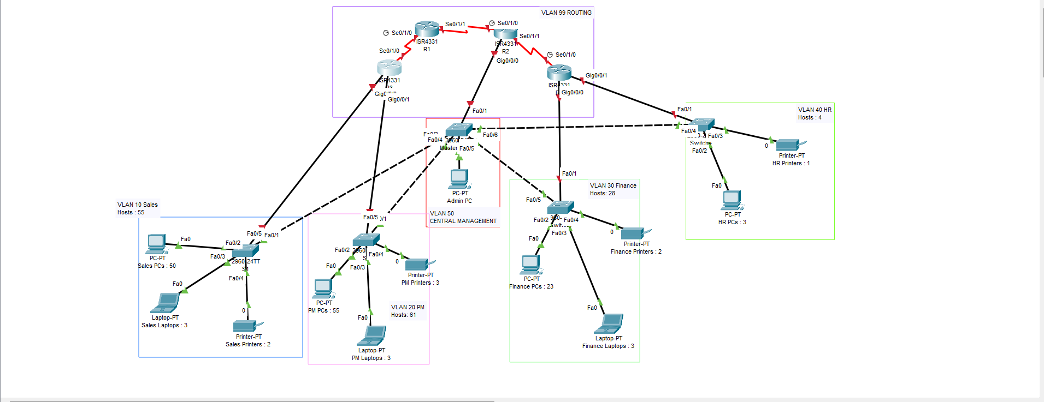

VLANS

There will be 6 VLANs in our network.
- VLAN 10 (Sales)
- VLAN 20 (Product management)
- VLAN 30 (Finance)
- VLAN 40 (HR)
- VLAN 50 (Management)
- VLAN 99 (Routing)

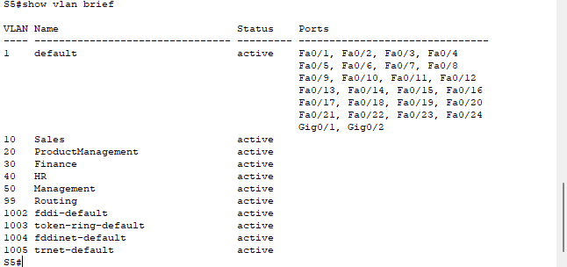This was done using the commands:
- vlan 10
- name Sales
- exit
Repeat for all the others until you got all the VLANS required for the project

Subnet Table

All the terms that I will be using, come from the Packet Tracer file, but here is a recap of it. R1 – Router1, R2 – Router2, R3 – Router3, R4 – Router4, S1 – Switch1 (Sales), S2 – Switch2 (Product Management), S3 – Switch3 (Finance), S4 – Switch4 (HR).

IPV4 Subnetting

In our design, since not a single subnet suits our needs, we will divide the 192.168.33.0/24 into:
VLAN 10 (Sales) - /26 since we need to hold 55 hosts, and /26 is the one that allows us to use 1 – 4 subnets with a maximum host number of 64 hosts, 62 which are usable
VLAN 20 (Product Management) - /26 again since we need 61 hosts, and this subnet mask allows us to use 64 hosts, 62 usable
VLAN 30 (Finance) - /27 since we need to have 28 hosts, and /27 is the one that allows us to use 1 – 8 subnets with a total number of 32 hosts, with 30 of them being usable
VLAN 40 (HR) - /29 since we need 4 hosts, but we cannot use /30 since only 2 are usable, instead we use /29 which has 8 total addresses, and 6 available for us to use
VLAN 50 (Management) - /27 since we need 2 which are the admin pc and server, plus the 4 switches and the router R2 connecting to the VLAN. A /27 will be more than enough to give us room for adding even more divisions to the Central Management VLAN
VLAN 99 (Routing) – Three /30 subnets for each, since all we need is 1 usable host for them, but the /30 subnet gives us 2 that we can use, which more than satisfies the requirements

Subnet R3 – S1: 192.168.33.0/26, Usable IPs: 192.168.33.1 – 192.168.33.62, Broadcast: 192.168.33.63, Dotted Decimal: 255.255.255.192
Subnet R3 – S2: 192.168.33.64/26, Usable IPs: 192.168.33.65 – 192.168.33.126, Broadcast: 192.168.33.127, Dotted Decimal: 255.255.255.192
Subnet R4 – S3: 192.168.33.128/27, Usable IPs: 192.168.33.129 – 192.168.33.158, Broadcast: 192.168.33.159, Dotted Decimal: 255.255.255.224
Subnet R4 – S4: 192.168.33.160/29, Usable IPs: 192.168.33.161 – 192.168.33.166, Broadcast: 192.168.33.167, Dotted Decimal: 255.255.255.248
Subnet R2 – S5: 10.10.1.0/27, Usable IPs: 10.10.1.1–10.10.1.6, Broadcast: 10.10.1.7, Dotted Decimal: 255.255.255.224
Subnet R1 – R2: 192.168.33.168/30, Usable IPs: 192.168.33.169 – 192.168.33.170, Broadcast: 192.168.33.171, Dotted Decimal: 255.255.255.252
Subnet R1 – R3: 192.168.33.172/30, Usable IPs: 192.168.33.173 – 192.168.33.174, Broadcast: 192.168.33.175, Dotted Decimal: 255.255.255.252
Subnet R2 – R4: 192.168.33.176/30, Usable IPs: 192.168.33.177 – 192.168.33.178, Broadcast: 192.168.33.179, Dotted Decimal: 255.255.255.252

IPV6 Subnetting

In our case since we are using ipv6 to subnet our network as well, we will use the subnet of /64 for all of our VLANs, since it fulfills all our requirements, with more than 18,000,000,000,000,000 host addresses available for us to use.

Subnet R3 – S1: 2001:DB8:10::/64, Usable IPs: 2001:DB:10:1–2001:DB8:10:FFFF:FFFF:FFFF:FFFF:FFFF, Default Gateway: 2001:DB8:10::1/64
Subnet R3 – S2: 2001:DB8:20::/64, Usable IPs: 2001:DB:20:1–2001:DB8:20:FFFF:FFFF:FFFF:FFFF:FFFF, Default Gateway: 2001:DB8:20::1/64
Subnet R4 – S3: 2001:DB8:30::/64, Usable IPs: 2001:DB:30:1–2001:DB8:30:FFFF:FFFF:FFFF:FFFF:FFFF, Default Gateway: 2001:DB8:30::1/64
Subnet R4 – S4: 2001:DB8:40::/64, Usable IPs: 2001:DB:40:1–2001:DB8:40:FFFF:FFFF:FFFF:FFFF:FFFF, Default Gateway: 2001:DB8:40::1/64
Subnet R2 – S5: 2001:DB8:50::/64, Usable IPs: 2001:DB:50:1–2001:DB8:50:FFFF:FFFF:FFFF:FFFF:FFFF, Default Gateway: 2001:DB8:50::1/64
Subnet R1 – R2: 2001:DB8:1::/64, Usable IPs: 2001:DB:1:1–2001:DB8:1:FFFF:FFFF:FFFF:FFFF:FFFF, Default Gateway: 2001:DB8:1::1/64
Subnet R1 – R3: 2001:DB8:2::/64, Usable IPs: 2001:DB:2:1–2001:DB8:2:FFFF:FFFF:FFFF:FFFF:FFFF, Default Gateway: 2001:DB8:2::1/64
Subnet R2 – R4: 2001:DB8:3::/64, Usable IPs: 2001:DB:3:1–2001:DB8:3:FFFF:FFFF:FFFF:FFFF:FFFF, Default Gateway: 2001:DB8:3::1/64

Addressing Table

In this table we can see the IP addresses for the demo devices that we have used in the packet tracer file, and all the other devices IPs can be found in the range of IPV4 addresses in the VLAN rows.
VLAN/Device | IPv4 Address | Subnet Mask | Default Gateway | IPv6 Address | Prefix Length | IPv6 Gateway
Sales VLAN | 192.168.33.0 - 192.168.33.62
Sales PC | 192.168.33.2 | 255.255.255.192 | 192.168.33.1 | 2001:db8:10::2 | /64 | 2001:db8:10::1
Sales Laptop | 192.168.33.3 | 255.255.255.192 | 192.168.33.1 | 2001:db8:10::3 | /64 | 2001:db8:10::1
Sales Printer | 192.168.33.4 | 255.255.255.192 | 192.168.33.1 | 2001:db8:10::4 | /64 | 2001:db8:10::1
Gateway (R3) | 192.168.33.1 | 255.255.255.192 | - | 2001:db8:10::1 | /64 | -
Product Management VLAN | 192.168.33.64 - 192.168.33.126
Product PC | 192.168.33.66 | 255.255.255.192 | 192.168.33.65 | 2001:db8:20::2 | /64 | 2001:db8:20::1
Product Laptop | 192.168.33.67 | 255.255.255.192 | 192.168.33.65 | 2001:db8:20::3 | /64 | 2001:db8:20::1
Product Printer | 192.168.33.68 | 255.255.255.192 | 192.168.33.65 | 2001:db8:20::4 | /64 | 2001:db8:20::1
Gateway (R3) | 192.168.33.65 | 255.255.255.192 | - | 2001:db8:20::1 | /64 | -
Finance VLAN | 192.168.33.128 - 192.168.33.158
Finance PC | 192.168.33.130 | 255.255.255.224 | 192.168.33.129 | 2001:db8:30::2 | /64 | 2001:db8:30::1
Finance Laptop | 192.168.33.131 | 255.255.255.224 | 192.168.33.129 | 2001:db8:30::3 | /64 | 2001:db8:30::1
Finance Printer | 192.168.33.132 | 255.255.255.224 | 192.168.33.129 | 2001:db8:30::4 | /64 | 2001:db8:30::1
Gateway (R4) | 192.168.33.129 | 255.255.255.224 | - | 2001:db8:30::1 | /64 | -
HR VLAN | 192.168.33.160 - 192.168.33.166
HR PC | 192.168.33.162 | 255.255.255.248 | 192.168.33.161 | 2001:db8:40::2 | /64 | 2001:db8:40::1
HR Printer | 192.168.33.163 | 255.255.255.248 | 192.168.33.161 | 2001:db8:40::3 | /64 | 2001:db8:40::1
Gateway (R4) | 192.168.33.161 | 255.255.255.248 | - | 2001:db8:40::1 | /64 | -
Management VLAN | 10.10.1.0 - 10.10.1.32
Admin PC | 10.10.1.2 | 255.255.255.224 | 10.10.1.1 | 2001:db8:50::2 | /64 | 2001:db8:50::1
Gateway (R2) | 10.10.1.1 | 255.255.255.224 | - | 2001:db8:50::1 | /64 | -
Routing VLAN | 192.168.33.160 - 192.168.33.171
R1 ↔ R2 (Serial0/1/1) | 192.168.33.170 | 255.255.255.252 | - | 2001:db8:1::1 | /64 | -
R2 ↔ R4 (Serial0/1/0) | 192.168.33.178 | 255.255.255.252 | - | 2001:db8:3::1 | /64 | -
R1 ↔ R3 (Serial0/1/0) | 192.168.33.174 | 255.255.255.252 | - | 2001:db8:2::1 | /64 | -

Setting up the Interfaces IPV4

Setting up R3 interfaces using the commands:
- interface gi0/0/0
- ip address 192.168.33.1 255.255.255.192
- no shutdown
- exit
- interface gi0/0/1
- ip address 192.168.33.65 255.255.255.192
- no shutdown
- interface se0/1/0 (for the serial interface connecting R3-R1)
- ip address 192.168.33.173 255.255.255.252
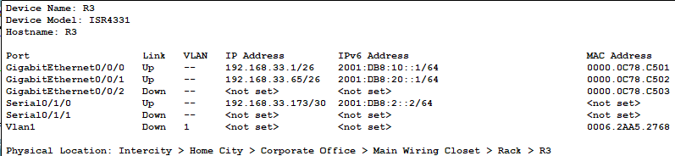
With this command we are able to set the interface in the net mask of 255.255.255.192/255.255.255.192, with the ip of 192.168.33.1/192.168.33.65, which will be the default gateway of Sales/Product Management VLANs. Afterwards we can configure the devices in S1 and S2, such as the laptops, PCs, and printers, to have a ip in the range of the subnet.

Setting up R4 interfaces
- interface gi0/0/0
- ip address 192.168.33.129
- no shutdown
- exit
- interface gi0/0/1
- ip address 192.168.33.161
- no shutdown
- exit
- interface se0/1/0 (for the interface R4-R2)
- ip address 192.168.33.178 255.255.255.252
- no shutdown
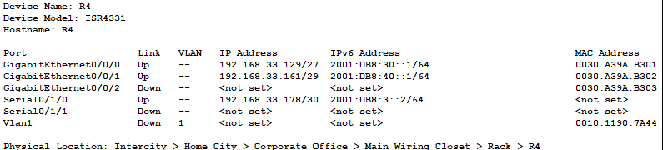
Here we do the same but for the interfaces of Finance/HR VLANS.

Setting up the R1 interface:
- interface se0/1/0 (interface of R1-R3)
- ip address 192.168.33.174 255.255.255.252
- no shutdown
- exit
- interface se0/1/1 (interface R1-R2)
- ip address 192.168.33.169 255.255.255.252
- no shutdown
- exit
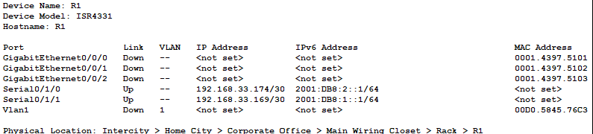
Here we are setting up the subnets between the serial interfaces connections between the routers. Since my design revolves around only 3 routers connecting the VLANS, the R1 will serve as the connecting router, where the traffic always passes through when routing, and communicating between divisions.

Setting R2 interface:
- interface se0/1/0 (interface R2-R1)
- ip address 192.168.33.170 255.255.255.252
- no shutdown
- exit
- interface se0/1/1 (interface R2-R4)
- ip address 192.168.33.177 255.255.255.252
- exit
- interface gi0/0/0
- ip address 10.10.1.1 255.255.255.224
- no shutdown
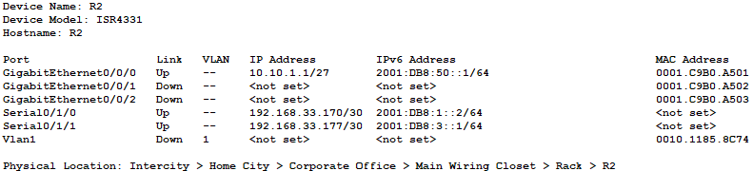
The gi0/0/0 is the interface where the Management VLAN 50 takes place, with the remote switch, server, and admin PC.

Setting up the Interfaces IPV6

The same is for the IPV6 connections, but first we have to enter the command: “ipv6 unicast-routing”, in each router in order to allow ipv6 communication inside our network.
R1 IPV6 interface configuration:
- ipv6 unicast-routing
- interface se0/1/0
- ipv6 address 2001:DB8:2::1/64
- no shutdown
- exit
- interface se0/1/1
- ipv6 address 2001:DB:1::1/64
- no shutdown
With this commands we set the default gateway in the serial connections for the connection R1-R2 and R1-R3

R2 IPV6 interface configuration:
- ipv6 unicast-routing
- interface se0/1/0
- ipv6 address 2001:DB8:1::2/64
- no shutdown
- exit
- interface se0/1/1
- ipv6 address 2001:DB8:3::1/64
- no shutdown
- exit
- interface gi0/0/0
- ipv6 address 2001:DB8:50::1/64
- no shutdown
In here we are configuring the default gateway of VLAN 50 to be 2001:DB8:50::1/64, so each device inside the VLAN should consist of a number between 50::2 etc.

R3 IPV6 interface configuration:
- ipv6 unicast-routing
- interface se0/1/0
- ipv6 address 2001:DB8:2::2/64
- no shutdown
- exit
- interface gi0/0/0
- ipv6 address 2001:DB8:10::1/64
- no shutdown
- exit
- interface gi0/0/1
- ipv6 address 2001:DB8:20::1/64
- no shutdown
Setting up the Default Gateway of VLAN 10 and VLAN 20. Devices inside VLAN 10 should have an ip in the range of 2001:DB8:10::2 etc., and VLAN 20 devices should be the same, but with its range being 2001:DB8:20::2 etc.

R4 IPV6 interface configuration:
- ipv6 unicast-routing
- interface se0/1/0
- ipv6 address 2001:DB8:3::2/64
- no shutdown
- exit
- interface gi0/0/0
- ipv6 address 2001:DB8:30::1/64
- no shutdown
- exit
- interface gi0/0/1
- ipv6 address 2001:DB8:40::1/64
- no shutdown
Setting the Default Gateway for VLAN 30 and VLAN 40. Same principal like the last two applies here as well, where VLAN 30 will have its devices in the ip range of 2001:DB8:30::2 etc., and for VLAN 40, 2001:DB8:40::2 etc.

Routing

IPV4 Routing

Now all that is left is to be able to communicate from VLAN to VLAN, even when the subnetting is not the same, and we can do this with routing. We will first discuss how I implemented this in IPV4, and afterwards about the IPV6 implementation.

R1 IPV4 routing:
- ip route 192.168.33.0 255.255.255.192 192.168.33.173
- ip route 192.168.33.64 255.255.255.192 192.168.33.173
- ip route 192.168.33.128 255.255.255.224 192.168.33.170
- ip route 192.168.33.160 255.255.255.248 192.168.33.170
- ip route 10.10.1.0 255.255.255.224 192.168.33.170

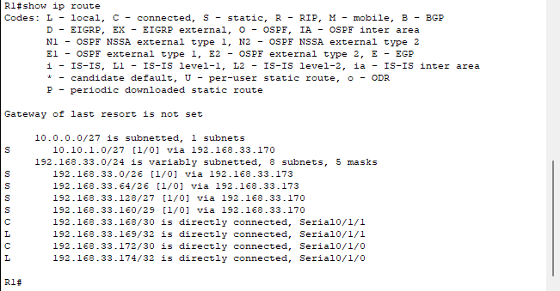
This commands will create the static routes, where we can connect even if we are not connected directly/locally via an interface to the VLAN. The first argument is which Subnet we would like to connect, the second argument is the net mask of the subnet, and the last argument is the IP of the interface which the VLAN connection is coming from. In our case the first two subnets that we are routing come from R3, so we put the IP of that interface. The other 3 all come from the R2, so the third argument for them is R2’s ip.

R2 IPV4 routing:
- ip route 192.168.33.0 255.255.255.192 192.168.33.169
- ip route 192.168.33.64 255.255.255.192 192.168.33.169
- ip route 192.168.33.128 255.255.255.224 192.168.33.178
- ip route 192.168.33.160 255.255.255.248 192.168.33.178

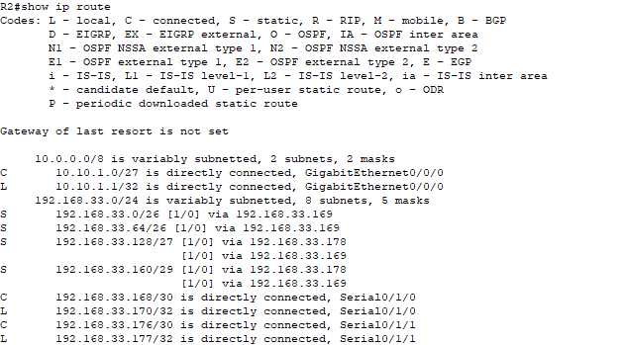
In this case we do not need a static route for VLAN 50 since it is already routed locally, via Gigabit Ethernet.
R3 IPV4 routing:
- ip route 192.168.33.128 255.255.255.224 192.168.33.174
- ip route 192.168.33.160 255.255.255.248 192.168.33.174
- ip route 10.10.1.0 255.255.255.224 192.168.33.174

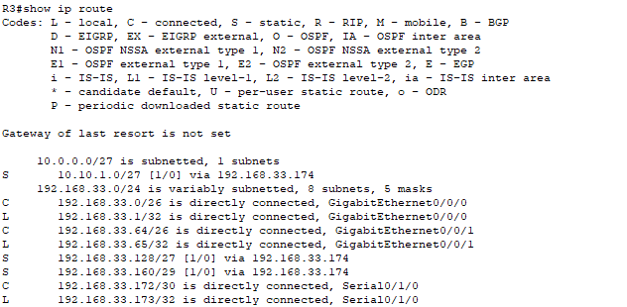
Looking at the commands, we can notice that VLAN 10 and 20 are locally connected to the Router, so there is no need for a static route.

R4 IPV4 route:
- ip route 192.168.33.0 255.255.255.192 192.168.33.177
- ip route 192.168.33.64 255.255.255.192 192.168.33.177
- ip route 10.10.1.0 255.255.255.224 192.168.33.177
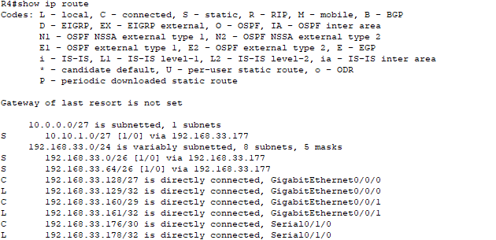

IPV6 Routing

The same principals apply here as well, just in the ipv6 format.

R1 IPV6 routing:
- ipv6 route 2001:DB8:1::/64 2001:DB8:2::1
- ipv6 route 2001:DB8:30::/64 2001:DB8:2::1
- ipv6 route 2001:DB8:40::/64 2001:DB8:2::1
- ipv6 route 2001:DB8:50::/64 2001:DB8:2::1
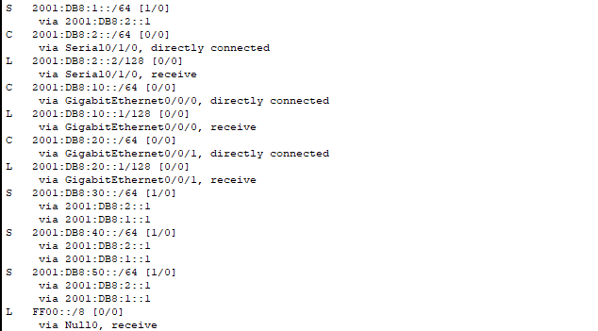

R2 IPV6 routing:
- ipv6 route 2001:DB8:10::/64 2001:DB8:1::1
- ipv6 route 2001:DB8:20::/64 2001:DB8:1::1
- ipv6 route 2001:DB8:30::/64 2001:DB8:3::2
- ipv6 route 2001:DB8:40::/64 2001:DB8:3::2
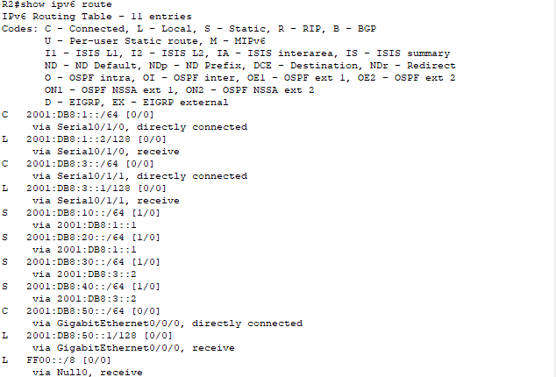

R3 IPV6 routing:
- ipv6 route 2001:DB8:1::/64 2001:DB8:2::1
- ipv6 route 2001:DB8:30::/64 2001:DB8:2::1
- ipv6 route 2001:DB8:40::/64 2001:DB8:2::1
- ipv6 route 2001:DB8:50::/64 2001:DB8:2::1
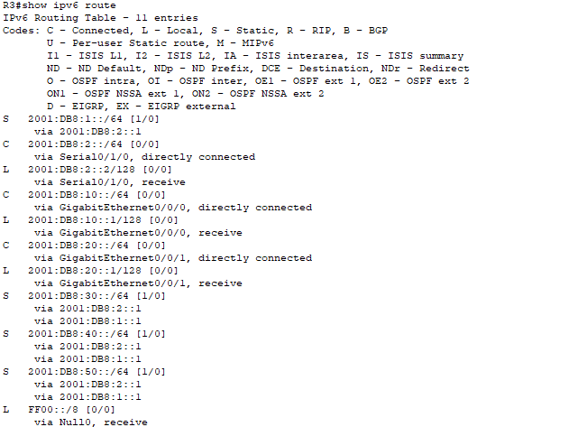

R4 IPV6 routing:
- ipv6 route 2001:DB8:10::/64 2001:DB8:3::1
- ipv6 route 2001:DB8:20::/64 2001:DB8:3::1
- ipv6 route 2001:DB8:50::/64 2001:DB8:3::1

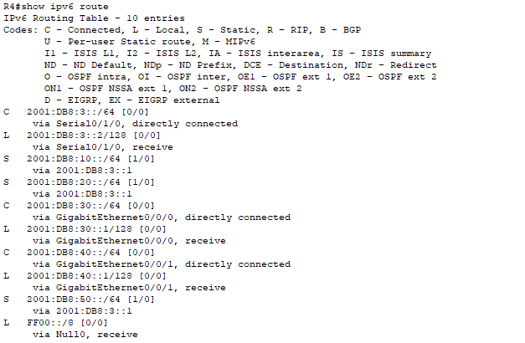

Security and Configurations

The passwords for all the routers and switches are:
- Console Password: Cisco
- Enable Password: Class
- Secret Password: Class123

The message of the day, for simplicity sake, have all been configured to display the “Unauthorized access is strictly forbidden!!!”.

Steps to Create the Passwords

Creating the console Password:
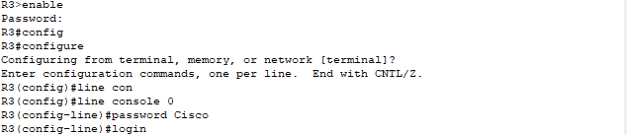

Creating Enable and Secret Password
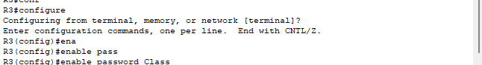
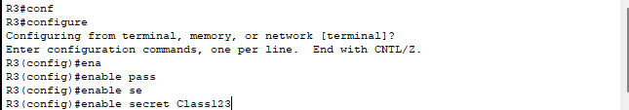

Steps to Create MOTD and encrypt the passwords

Creating the message of the day banner

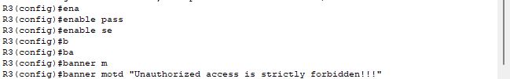

Encrypting all the passwords

In the end after creating all the password we encrypt them so their information in the running-config is visible as a hash instead of the actual information.

